Bansilal Ramnath Agarwal Charitable Trust’s

Vishwakarma Institute of Technology, Pune
(An autonomous Institute of Savitribai Phule Pune University)

Department of Computer Engineering



Subject: Design and Analysis of Algorithm

Class & Year: TY-CS-D 2025-26

PRN | Roll No | Name | Email
11811011 | 44 | Sahil Betal | sahil.betal18@vit.edu

LAB 1 : Finding max element and playing cards.

Finding maximum element Objective:
  - To determine the largest element from a given list of numbers
  - To understand linear traversal of arrays
  - To apply comparison-based problem solving

Problem Statement:
Given an array of n elements, find the maximum (largest) element present in the array.

Algorithm / Strategy:
- Start
- Input number of elements n
- Read array elements
- Initialize max = arr[0]
- Traverse the array from index 1 to n-1
- For each element:
  - If arr[i] > max, update max = arr[i]
- Print the maximum element
- End

Time Complexity:
- Best Case: O(n)
- Average Case: O(n)
- Worst Case: O(n)

Space Complexity:
- O(1)

Code:

n = int(input("Enter number of elements: "))

arr = []
print("Enter elements:")
elements = input().split()
for i in range(n):
arr.append(int(elements[i]))

max_val = arr[0]

for i in range(1, n):
if arr[i] > max_val:
max_val = arr[i]

print("Maximum element = " + str(max_val))

Output:
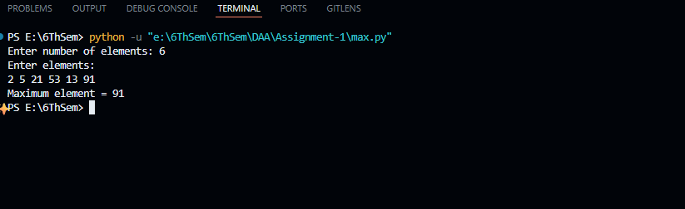

Playing Cards(Finding Highest Card) Objective:
  - To simulate a deck of playing cards using arrays
  - To assign values to card ranks
  - To determine the highest card based on rank

Problem Statement:
Given a standard deck of 52 playing cards (4 suits × 13 ranks), identify the highest card based on rank value.

Algorithm / Strategy
- Start
- Define arrays for:
  - Suits → {Hearts, Diamonds, Clubs, Spades}
  - Ranks → {A, 2, 3, ..., 10, J, Q, K}
- Initialize:
  - maxValue = 0
  - highestCard = ""
- For each suit:
  - For each rank:
    - Convert rank to value using function
    - If value > maxValue:
      - Update maxValue
      - Update highestCard
- Print highestCard
- End

Code:
from collections import deque

suits = ["♠", "♥", "♦", "♣"]
ranks = ["A", "2", "3", "4", "5", "6", "7", "8", "9", "10", "J", "Q", "K"]
deck = [f"{r}{s}" for s in suits for r in ranks]

print("Deck created.")
print(deck)

initial_card = input("\nEnter the card to remove (e.g., A♠): ").strip()

if initial_card not in deck:
raise ValueError("Card not found in deck!")

initial_index = deck.index(initial_card)
deck.remove(initial_card)

print(f"\nRemoved card: {initial_card}")
print(f"Original position was index {initial_index}")

deck = deque(deck)

shift = int(input("\nEnter shift value (e.g., 1 = right, -1 = left): "))

history = []
step = 0

while True:
step += 1
deck.rotate(shift)

temp_deck = list(deck)
temp_deck.insert(initial_index, initial_card)

history.append({
"step": step,
"shift": shift,
"deck_top": temp_deck[:5], # preview
"card_position": temp_deck.index(initial_card)
})

print(f"\nStep {step}")
print(f"Top 5 cards: {temp_deck[:5]}")
print(f"{initial_card} is at position {temp_deck.index(initial_card)}")

if temp_deck.index(initial_card) == initial_index:
print("\n🎯 Initial card returned to its original position!")
break

print("\n=== SHIFT DATABASE ===")
for record in history:
print(record)

Output:

